Disaster Recovery Execution Plan

**SQL Server, PKS-NJ-SQL2**  
Remove replication setup from NJ server.  
Follow the steps.  
1. Select the subscription as shown in image.

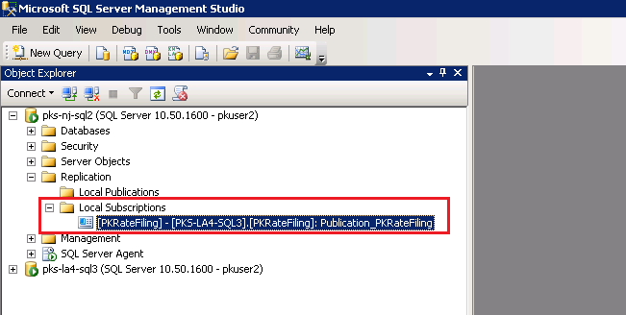

2. Right click on selected Subscription and click on Delete. A popup dialog box would be displayed as shown in image. Click on Yes button from the pop up dialog box.  
  
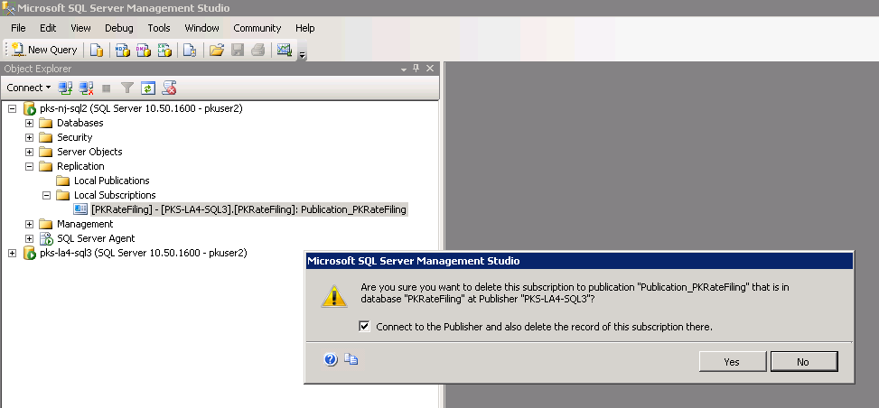

**Batch Jobs**  
Batch jobs are deployed on two servers, PKS-NJ-SOLR and PKS-NJ-WORKER. We would look at each one of them.  
  
***PKS-NJ-SOLR***1. Open service manager, as shown in image.  
  
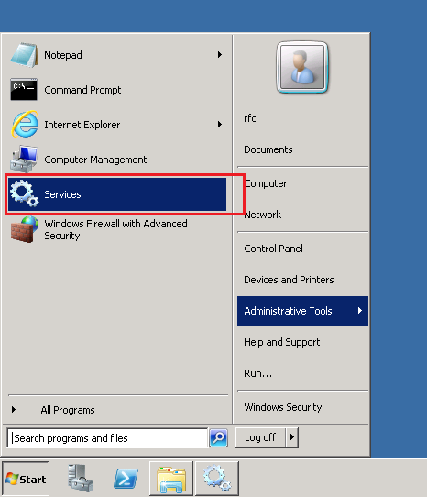

2. We need to start three process, those are PKRFWorker, PKAIIndexer, RateFilingLogWorker. All three processes should be started in same way as mentioned in image below.  
  
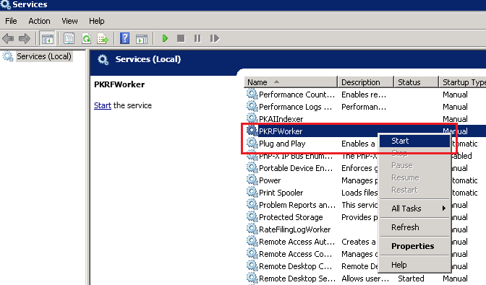

**Note for Abacus:**

If SMTP server is located in LA, then we need to change SMTP settings. Changes should be made in   
1. RateFilingWorker.exe located in ‘C:\Program Files (x86)\Windows Services\01 PKRFWorker\’  
  
If location of \\pk.local is also located in LA, then we need to change DAIntake, DAValid, DAInvalid paths. Changes should be made in   
1. Indexer.exe located in ‘C:\Program Files (x86)\Windows Services\02 AutoIndexer\’.  
2. RateFilingWorker.exe located in ‘C:\Program Files (x86)\Windows Services\01 PKRFWorker\’. In appsettings tag, you would need to change the value for ‘OriginalFilingPdfPath’.

***PKS-NJ-WORKER***  
1. Open service manager.  
2. Start ‘PKRateWatch’ process.

**Note for Abacus:**

If SMTP server is located in LA, then we need to change SMTP settings. Changes should be made in   
1. RWReportingService.exe located in ‘C:\Program Files (x86)\Windows Services\03 Underwriting\’

***PKS-NJ-WEB2***

Login in this server by username ‘PKS-NJ-WEB2\abacus’ and password as ‘Un1v3r53’.

1. Open ‘Computer Management’, as shown in image.

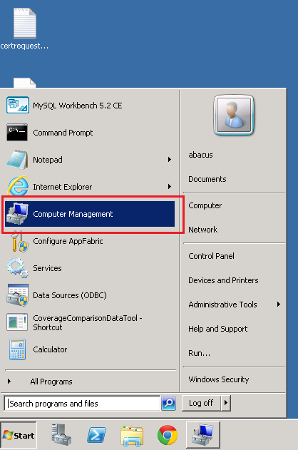

2. In ‘Computer Manager’, click on   
System Tools -- Task Scheduler – Task Scheduler Library – PKRatefilingTasks

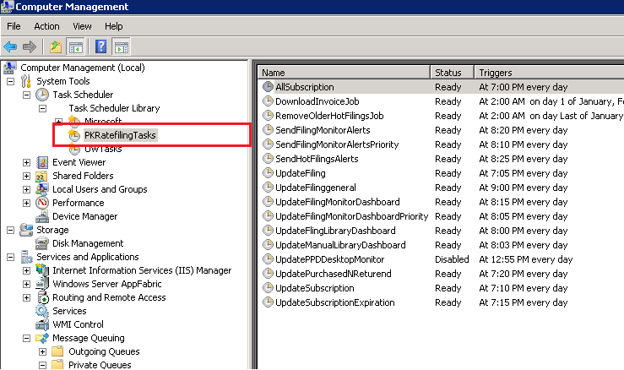

3. On right hand side panel, you can view all task related to ‘PKRFWorker’ service with their respective scheduled times. You can see each task is having Status as ‘Disabled’. Enable those tasks by following these steps.  
Click on each task – right click and click on enable, as shown in image.

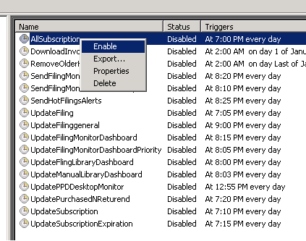

Do these steps for all the tasks except ‘UpdatePPDDesktopMonitor’ (keep this task in ‘Disable’ mode only).

4. Click on System Tools -- Task Scheduler – Task Scheduler Library – UWTasks  
  
5. On right hand side panel, you can view all task related to ‘PKRateWatch’ service with their respective scheduled times. You can see each task is having Status as ‘Disabled’. Change status of ‘CompanyRateChange’ task only to ‘Enable’ by following these steps. Click on ‘CompanyRateChange’ task -- right click and click on enable.

**Note for Abacus:**

If SMTP server is located in LA, then we need to change SMTP settings. Changes should be made in   
1. Web.config located in ‘D:\Sites\RateFiling\’  
  
If location of \\pk.local is in LA, then we would need another location that we can point to. Changes should be made in   
1. Web.config located in ‘D:\Site\RateFiling\’. In appsettings tag, you would need to change the value for ‘CustomDocumentUploadPath’ and ‘OriginalFilingPdfPath’.